**Lab 1: Basic GATE operations**

**Question: Execute the following Linux commands on Linux terminal of your choice and verify the output.**

1. **Whoami**

**Command Output:**



1. **PWD**

**Command Output:**



1. **ls**

**Command Output:**



1. **ls -R**

**Command Output:**

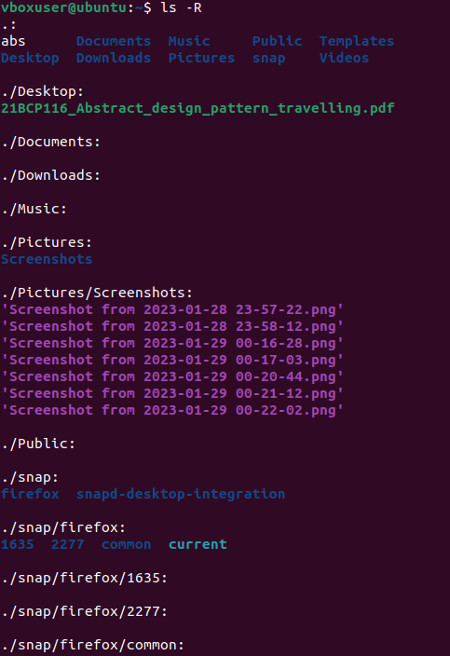

1. **ls -a**

**Command Output:**

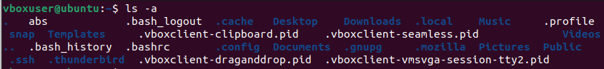

1. **History**

**Command Output:**

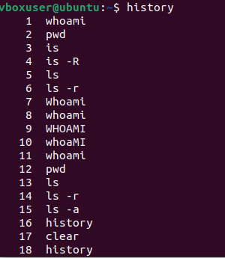

1. **Clear**

**Command Output:**

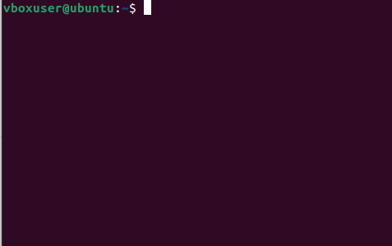

1. **echo**

**Command Output:**



1. **touch**

**Command Output:**



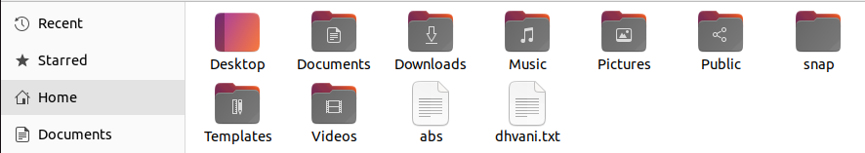

1. **rm**

**Command Output:**



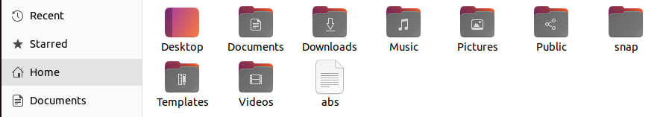

1. **mkdir**

**Command Output:**



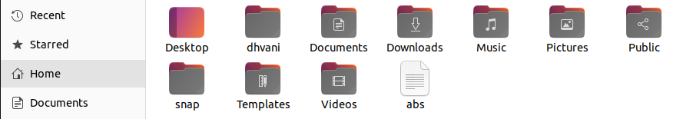

1. **rmdir**

**Command Output:**



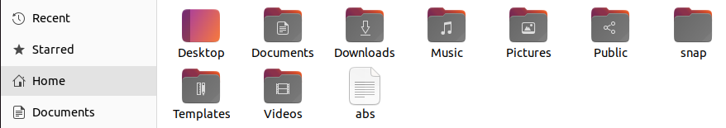

1. **mv**

**Command Output:**



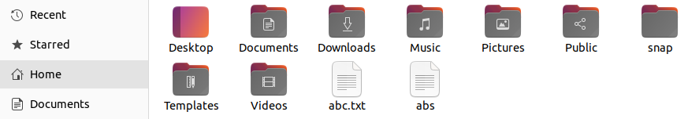

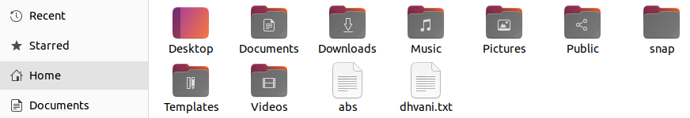

1. **cd**

**Command Output:**



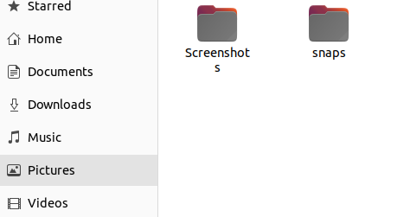

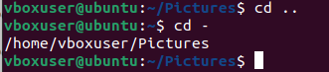

1. **cmp**

**Command Output:**

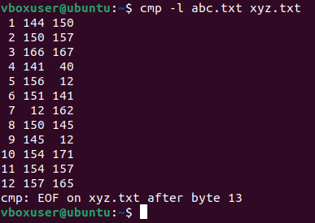

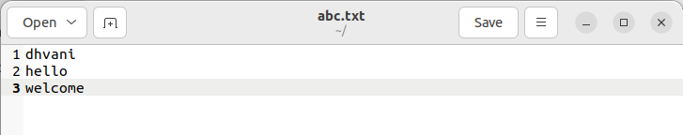

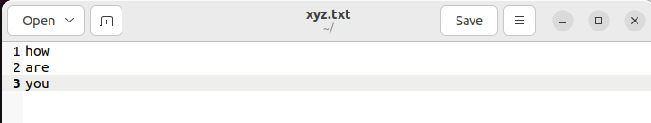

1. **cat**

**Command Output:**

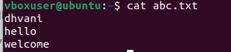







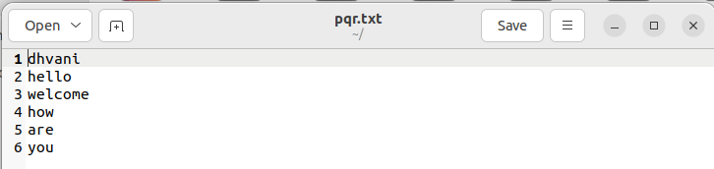

1. **cal**

**Command Output:**



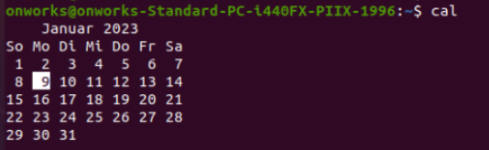

1. **cal 2018**

**Command Output:**



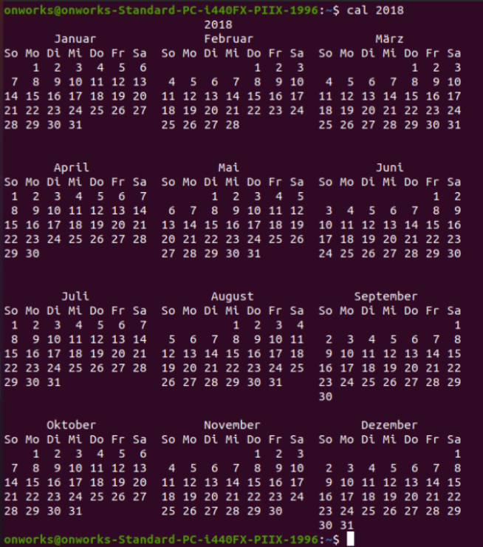

1. **passwd**

**Command Output:**

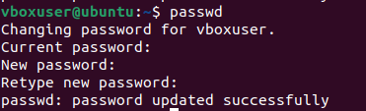

1. **grep**

**Command Output:**



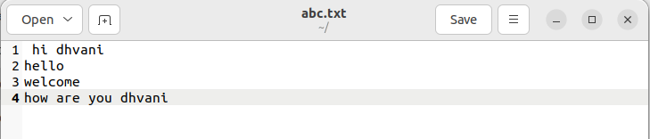

1. **free**

**Command Output:**

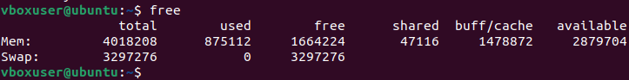

1. **uname**

**Command Output:**



1. **uname -a**

**Command Output:**



1. **uname -s**

**Command Output:**



1. **uname -n**

**Command Output:**



1. **groups**

**Command Output:**



1. **comm**

**Command Output:**

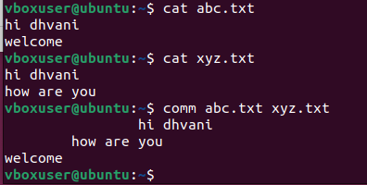

1. **date**

**Command Output:**



1. **date -d**

**Command Output:**



1. **--date**

**Command Output:**



1. **chmod**

**Command Output:**

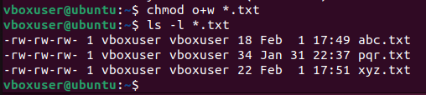

1. **wc**

**Command Output:**

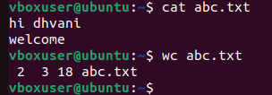

1. **ps**

**Command Output:**

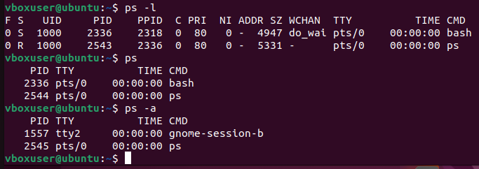

**34.top**

**Command Output:**

